BLOOMBERG EXERCISE #1: STOCK ANALYSIS

- Essay: In two paragraphs, explain fundamental stock analysis in your own words. Include in your explanation the multiplier (P/E) valuation model, relative valuation of a stock’s growth rates and how its capitalization affects the appropriate risk premium for the stock. Consider also models for estimating earnings per share, and methods for estimating appropriate P/E multiples.
Bloomberg Part: Use Bloomberg to begin to evaluate Sprouts Farmers Market (Ticker: SFM) using fundamental analysis. Turn in the 2-paragraph essay along with the following items:

- Using the DES (Description) screen, find:
- Full company description.
- # of employees.
- Any other important, relevant information for your company. (Basic ratios, rates, etc.?)

- Using the RELS (Related Securities) screen, find:
- What’s relevant to your company’s financial position?
  - Example: # of preferred securities, # of bank loans (What are they; how much?).

- Using the CF (Company Filings) screen:
- Review Latest 10K and summarize the following:
  - Products/Services Summary.
  - Competition Summary.
  - Other company specific relevant data.

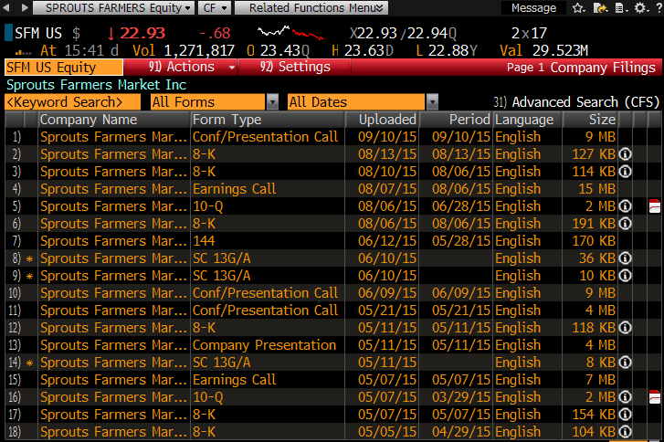
To view only 10-Ks, click into the amber ‘All Forms’ box and select 10-K. Use the most recent upload.

- Using the HDS (Major Holders) and OWN (Equity Ownership) screen, find:
- Top 5 holders: (HDS)
  - Amount held.
  - % Outstanding.
- Top 5 ownership types (by %). (OWN)
- % of institutional shares held.
- % of insider shares held.
- Are “smart” people holding the stock?

- Using the SPLC (Supply chain) screen (using company exposure), find:
- # of Suppliers:
  - Top 5 suppliers.
- # of Customers:
  - Top 5 customers.
- # of Peers
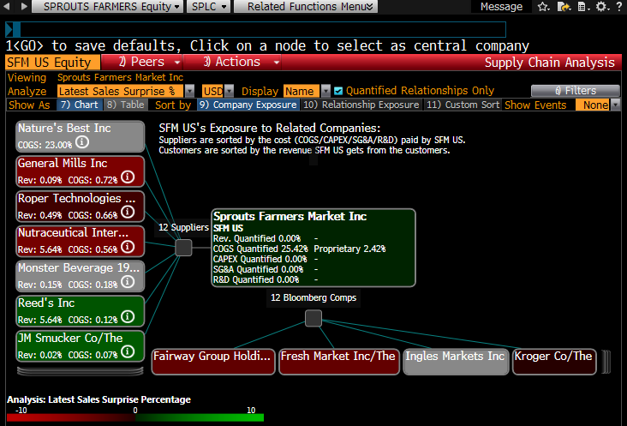
Make sure you have 9) Company Exposure selected.

- Using the DDIS (Debt Distribution) screen, find:
- What does their debt look like? (# issues, total $)
- Maturity schedule.

- Using the AGGD (Debt Holders) screen, find:
- Do they have “smart” debt holders?

- Using the BRC (Research on Company) screen, find:
- Relevant recent news:
  - New products, services, etc.

- Using the DRSK (Credit Risk) screen, find:
- Can they afford to pay their obligations?

- Using the CL (Company Litigation) screen, find:
- Are there any red flags?

